COVER COUGH AND SNEEZES
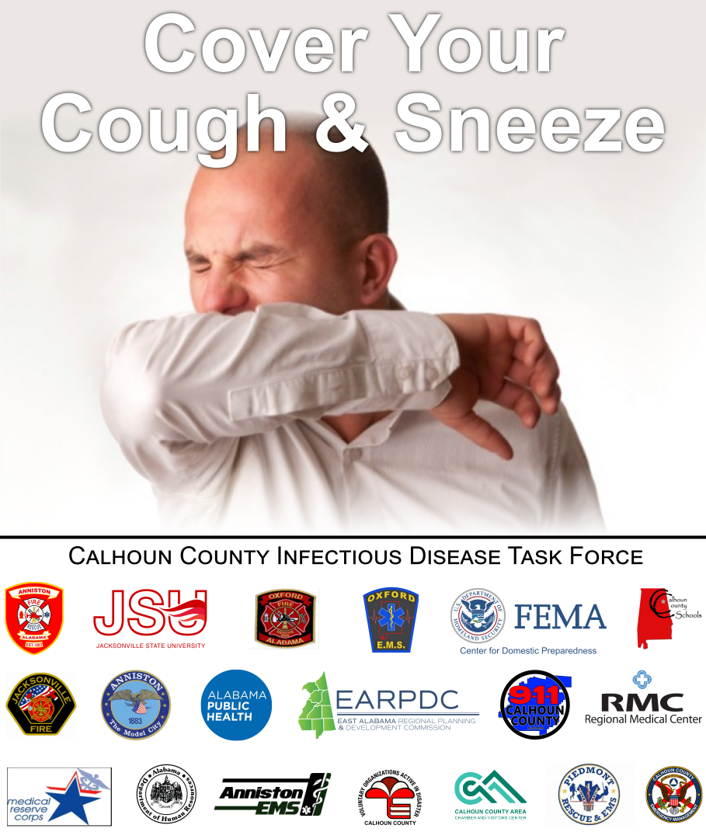Graphic: Cover Cough & Sneeze

Message:

Do your part to protect yourself and others from infectious diseases such as Flu & Covid-19

Cover Your Coughs and Sneezes
- Cover your coughs and sneezes with either a tissue or your upper sleeve.
- Droplets from a cough or sneeze can travel up to six feet.
- Avoid crowds and shaking hands during outbreaks.
- Avoid touching your eyes, nose, and mouth.
​
​
STAY HOME WHEN SICK
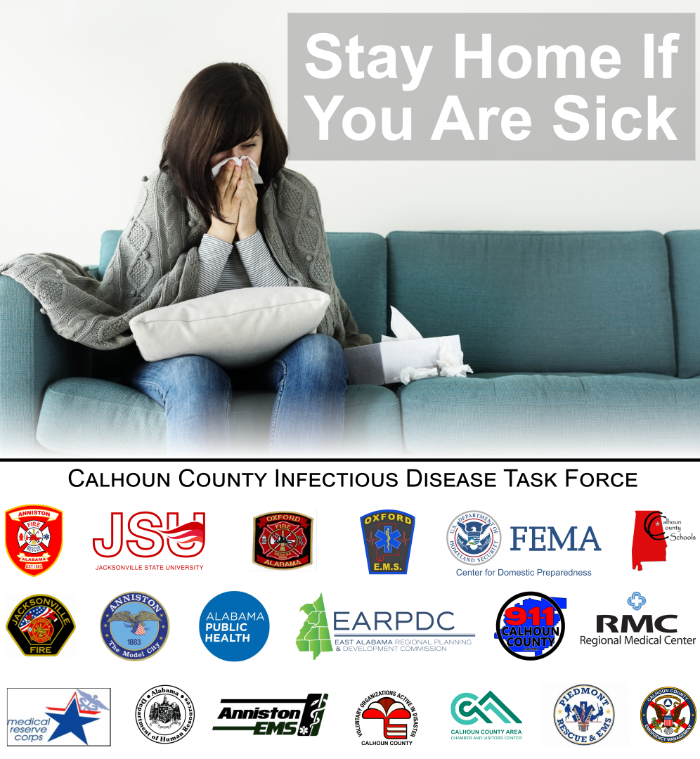Graphic: Stay Home

Message:
Do your part to protect yourself and others from infectious diseases such as Flu & Covid-19
Stay at home when you have a fever of 100 degrees F or higher.
Return to normal social and work activities after you've been fever-free without taking fever reducing medicine for 24 hours.
Other flu symptoms may include:
- Dry cough
- Sore throat
- Headache
- Extreme tiredness
- Runny or stuffy nose
- Muscle aches
- Nausea
- Vomiting
- Diarrhea
- Chills
​
​WASH YOUR HANDS
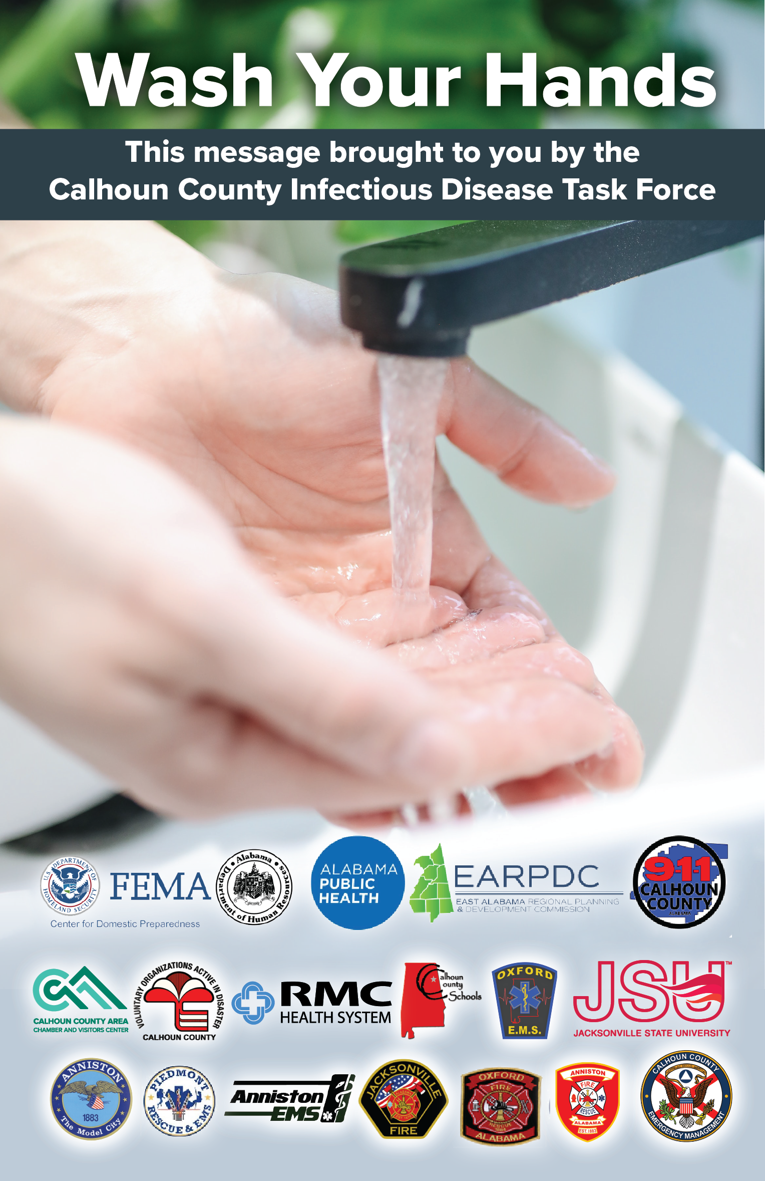Graphic: Wash Hands

Message:

Do your part to protect yourself and others from infectious diseases such as Flu & Covid-19

Wash Your Hands
1. Wet your hands with warm running water and apply soap.
2. Rub hands together to make lather and scrub all surfaces for 20 seconds.
3. Rinse hands well under running water.
4. Dry your hands using a paper towel or air dryer.
5. If possible, use your paper towel to turn off the faucet.
No soap and water? Use alcohol-based hand gel.
1. Apply gel to palm.
2. Rub the gel over all surfaces and fingers until dry.
Wash your hands immediately after:
- Coughing
- Sneezing
- Using the bathroom
- Handling garbage, animals, and animal waste
- Handling dirty dishes, trash, and laundry
- Being in contact with sick people
- Touching doorknobs, phones, etc.

CLEAN AND DISINFECT
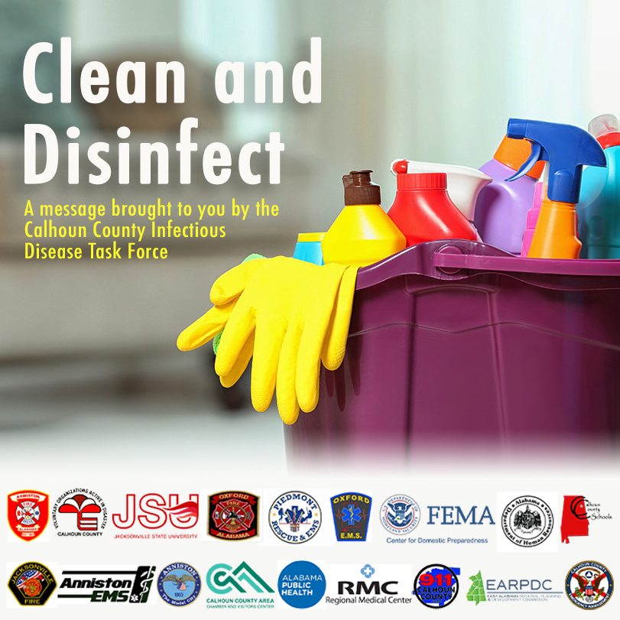Graphic: Clean and Disinfect
Message:

Do your part to protect yourself and others from infectious diseases such as Flu & Covid-19

Clean and Disinfect
- Frequently wipe surfaces like door knobs, phones, faucet, and food preparation areas with household disinfectant.
- Always follow label instruction.
- Keep disinfectants away from children, pets, heat, flames, and electrical equipment.
- Don't share linens, utensils, or dishes without washing first.
- Avoid "hugging" laundry from a sick person.

​TALKING POINTS
- The novel coronavirus or COVID-19, has some effects like influenza
- The majority of cases have been mild, only a small percentage have required hospitalization
- The most at risk for serious effects are elderly persons with underlying health conditions and individuals with preexisting respiratory conditions
- Criteria to be recommended for COVID-19 testing include: ○ fever (100.4 ≥) ○ coughing, ○ sore throat, ○ and/or shortness of breath
- People need to be prepared, not scared, and follow ADPH’s “Do 10”:
1. Get Vaccinated
2. Wash Your Hands
3. Cover Your Coughs and Sneezes
4. Stay Home With Fever
5. Stockpile Supplies
6. Clean and Disinfect
7. Know Your Office Emergency Plan
8. Learn Home Care
9. Call Your Doctor If Symptoms Get Worse
10. Stay Informed

